## Before you collaborate

##### A little bit of preparation goes a long way with this session. Here’s what you need to do to get going.

**10 minutes**

**1**

## Define your problem statement

##### What problem are you trying to solve? Frame your problem as a How Might We statement. This will be the focus of your brainstorm.

**5 minutes**

**2**

## Brainstorm

##### Write down any ideas that come to mind that address your problem statement.

**10 minutes**

**3**

## Group ideas

**TIP**

You can select a sticky note and hit the pencil [switch to sketch] icon to start drawing!

##### Take turns sharing your ideas while clustering similar or related notes as you go. Once all sticky notes have been grouped, give each cluster a sentence-like label. If a cluster is bigger than six sticky notes, try and see if you and break it up into smaller sub-groups.

**20 minutes**

**4**

## Prioritize

##### Your team should all be on the same page about what's important moving forward. Place your ideas on this grid to determine which ideas are important and which are feasible.

**20 minutes**

## After you collaborate

##### You can export the mural as an image or pdf to share with members of your company who might find it helpful.

**A Team gathering**

###### Divyadharshini

**PROBLEM**

**How might we [your problem statement]?**

**Muthamizh**

###### Ranganathan

**Rithik Roshan**

Major Reasons for heart attacks

**Quick add-ons**

Define who should participate in the session and send an invite. Share relevant information or pre-work ahead.

**TIP**

Add customizable tags to sticky notes to make it easier to find, browse, organize, and categorize important ideas as themes within your mural.

Preventive measures taken to avoid heart diseases

Due to

Major cause in

Eating too

Not physically active

Affected due much fast

People with family history

Lack of

Due to coronary

Metabolic

Inflammation

Cardiac

Torn blood

**A Share the mural**

**Share a view link** to the mural with stakeholders to keep

depression imbalance

to smoking

foods and

of heart

oxygen in

artery

syndrome

of arrest

vessels

**B Set the goal**

and anxiety

Low levels of estrogen

in food

Lack of

Changes in heart rate

Drug users

soft drinks

Caused by

disease

Diabetes and

blood

History of

disease

Autoimmune

Irregular heart

pericardities

Drug

Calcium deposits on

Hyperthyroidism

Intake of drugs and smoking

Healthy diet

Impove the

them in the loop about the outcomes of the session.

###### Export the mural

Think about the problem you'll be focusing on solving in

the brainstorming session.

###### C Learn how to use the facilitation tools

Use the Facilitation Superpowers to run a happy and

after

menopause

sleep

and blood

pressure

are affected amyloidosis Cholesterol

preeclampsia

condition

rhythms

misuse

walls of

arteries

Disturbances in sleep and intake of fastfood

Stress and Anxiety

Avoid the usage of drugs

Healthy lifestyle changes

### use of smart

watches

**B**

Export a copy of the mural as a PNG or PDF to attach to emails, include in slides, or save in your drive.

productive session.

[**Open article**](https://support.mural.co/en/articles/2113740-facilitation-superpowers)

###### Kishore

Electrolyte Imbalanced

Emotional

Not physically Active

Contact the doctor when there is a small change heart rhythms

Good sleep

**Keep moving forward**

###### Strategy blueprint

Improve the use of data analytics

Define the components of a new idea or strategy.

**Key rules of brainstorming**

To run an smooth and productive session

imbalances

High amount of cholesterol in blood

diet

Inflammatory diseases

stress and

depression

Oral contraceptive therapy

Obesity and excess

cholesterol in blood

Physical exercises

Maintain the diabetes and cholesterol in

[**Open the template**](https://app.mural.co/template/e95f612a-f72a-4772-bc48-545aaa04e0c9/984865a6-0a96-4472-a48d-47639307b3ca)

###### Customer experience journey map

Collect information of the person 24/7

Stay in topic.

Defer judgment.

Encourage wild ideas.

Listen to others.

**Importance**

If each of these

#### the blood

Understand customer needs, motivations, and

obstacles for an experience.

[**Open the template**](https://app.mural.co/template/b7114010-3a67-4d63-a51d-6f2cedc9633f/c1b465ab-57af-4624-8faf-ebb312edc0eb)

Brainstorm

& idea prioritization

### Use this template in your own brainstorming sessions so your team can unleash their imagination and start shaping concepts even if you're not sitting in the same room.

Go for volume. If possible, be visual.

tasks could get done without any difficulty or cost, which would have the most positive impact?

###### TIP

Participants can use their cursors to point at wh sticky notes should go the grid. The facilitator

ere on can ing

ng the d.

dataset with

Test the

Maintain a healthy lifestyle by intake of healthy food and physical exercises

###### Strengths, weaknesses, opportunities & threats

Identify strengths, weaknesses, opportunities, and threats (SWOT) to develop a plan.

[**Open the template**](https://app.mural.co/template/6a062671-89ee-4b76-9409-2603d8b098be/ca270343-1d54-4952-9d8c-fbc303ffd0f2)

[**Share template feedback**](https://muralco.typeform.com/to/CiqaHVat?typeform-source=app.mural.co)

**10 minutes** to prepare

**1 hour** to collaborate

**2-8 people** recommended

confirm the spot by us the laser pointer holdi

**H key** on the keyboar large set of

Compare normal values and monitor the patient's values

# data

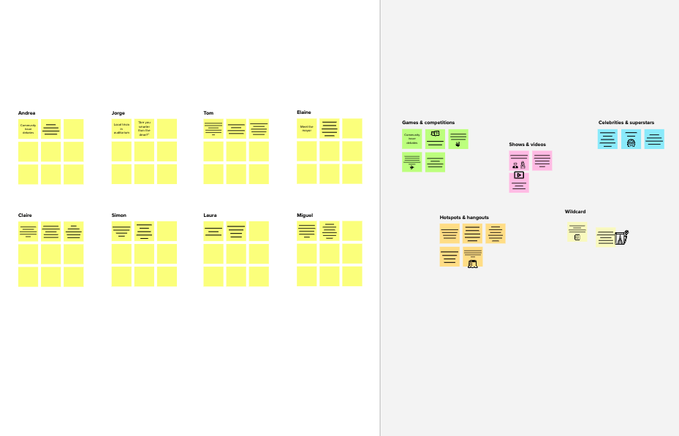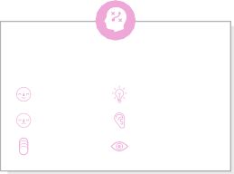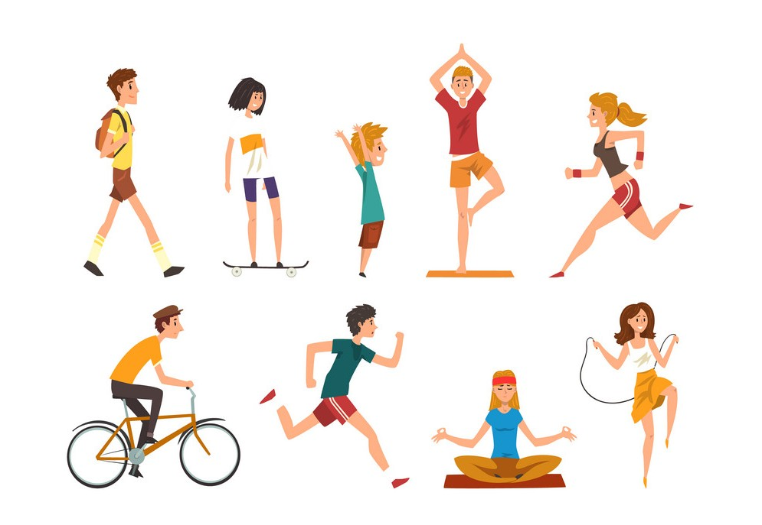

**Template**

**Feasibility**

Regardless of their importance, which tasks are more feasible than others? (Cost, time, effort, complexity, etc.)

**Need some inspiration?**

See a finished version of this template to kickstart your work.

[**Open example**](https://app.mural.co/template/e5a93b7b-49f2-48c9-afd7-a635d860eba6/93f1b98d-b2d2-4695-8e85-7e9c0d2fd9b9)



[**Share template feedback**](https://muralco.typeform.com/to/CiqaHVat?typeform-source=app.mural.co)